
Department of Computer Science

Lab Manual

of

MACHINE LEARNING

MCA521-4

Class Name: IV MCA

Master of Computer Application

2026

Prepared by: Verified by:

B K VISHNU  2547218  4MCAB | Dr. Rupali Sunil Wagh  Dr. Helen K Joy  Dr. Shivangi Singh

Department Overview
Department of Computer Science of CHRIST (Deemed to be University) strives to shape outstanding computer professionals with ethical and human values to reshape nation’s destiny. The training imparted aims to prepare young minds for the challenging opportunities in the IT industry with a global awareness rooted in the Indian soil, nourished and supported by experts in the field.

Vision
The Department of Computer Science endeavours to imbibe the vision of the University “Excellence and Service”. The department is committed to this philosophy which pervades every aspect and functioning of the department.

Mission
“To develop IT professionals with ethical and human values”. To accomplish our mission, the department encourages students to apply their acquired knowledge and skills towards professional achievements in their career. The department also moulds the students to be socially responsible and ethically sound.

Introduction to the Programme
Master of Computer Applications (MCA) is a post-graduate programme of CHRIST (Deemed to be University) and approved by the All India Council of Technical Education (AICTE). It is a two-year programme spread over six trimesters to bridge the chasm between computer studies and applications, bringing within reach of enthusiastic youngsters an excellent group of experienced and dedicated staff and experts, and an enviable infrastructure. MCA at CHRIST (Deemed to be University) strives to shape outstanding computer professionals with ethical and human values to reshape the nation’s destiny. The training programme aims to prepare young minds for challenging opportunities in the IT industry with a global awareness rooted in the Indian soil, nourished and supported by experts in the field. The Department is committed to the motto “Excellence and Service,” and this philosophy pervades every aspect of its functioning.

Programme Objective
This programme is conceptualised and designed based on the strong commitment of the
department to provide better quality education to the students. The principal objectives of this
course are to:
● Heighten technological awareness
● Train future industry specialists
● Encourage effective software development
● Provide research training
● Involve students in innovative research
● Produce graduates with a two-year professional education in Computer Science with
technical, professional, and communications skills.

Ethics and Human Values
1. Only proprietary or open-source software would be used for academic teaching and
learning purposes.
2. Copying of programs from the internet, friends or from other sources is strictly
discouraged since it impairs development of programming skills.
3. Unique Practical (Domain based) exercises ensure that the students don’t get involved in
code plagiarism.
4. Projects undertaken by students during the course are done in teams to improve
collaborative work and synergy between team members.
5. Projects involve modularization which initiates students to take individual responsibility
for common goals.
6. Passion for excellence is promoted among the students, be it in software development or
project documentation.
7. Giving due credit to sources during the seminar and research assignment is promoted
among the students
8. The course and its design enforce the practice of good referencing technique to improve
the sense of integrity.
9. Courses involving group discussions and debates on ethical practices and human values
are designed to sensitize the students in dealing with customers and members within the
Organization.

Programme Outcomes:
P01: Foundation Knowledge: Apply knowledge of mathematics, programming logic, and
coding fundamentals for solution architecture and problem-solving.
P02: Problem Analysis: Identify, review, formulate, and analyse problems primarily focussing on customer requirements using critical thinking frameworks.
P03: Development of Solutions: Design, develop and investigate problems with as an
innovative approach for solutions incorporating ESG/SDG goals.
PO4: Modern Tool Usage: Select, adapt, and apply modern computational tools such as the
development of algorithms with an understanding of the limitations including human biases.
P05: Individual and Teamwork: Function and communicate effectively as an individual or a
team leader in diverse and multidisciplinary groups. Use methodologies such as agile.
P06: Project Management and Finance: Use the principles of project management such as
scheduling, and work breakdown structure and be conversant with the principles of Finance for profitable project management.
P07: Ethics: Commit to professional ethics in managing software projects with financial aspects.
Learn to use new technologies for cyber security and insulate customers from malware
P08: Life-long learning: Change management skills and the ability to learn, keep up with
contemporary technologies and ways of working.

Programme Educational Objectives(PEO’s)
PEO1: Develop innovative and effective software solutions through research that addresses
real-world challenges, grounded in a commitment to continuous learning and adaptability.
PEO2: Advance the knowledge and practices in the field of computer applications through
lifelong learning and rigorous research, supporting professional growth and academic excellence.
PEO3: Exhibit ethical leadership, social responsibility to contribute and enhance community
well-being by innovating solutions.
MCA521-4 – MACHINE LEARNING
Course Name: MACHINE LEARNING Code: MCA521-4
Total Hours: 75
L + P + T: 3 + 4 + 0
Max Marks: 100
Credits: 4
Course Type: Core Course
Course Category: Theory &Practical
Course Description
Machine Learning is a key area in computer applications that focuses on building models capable of making predictions or informed decisions based on data. A strong understanding of machine learning enables students to analyze and interpret complex datasets, develop predictive models, and extract meaningful insights. This course covers a wide range of machine learning concepts and techniques, including supervised and unsupervised learning. It provides a solid theoretical foundation while emphasizing practical, hands-on experience with algorithms and real-world data. The course equips students with the knowledge and skills required to apply machine learning techniques across various domains using modern tools and methodologies.
Course Objectives
This course enables students to understand the fundamental concepts of Machine Learning, including its core principles, terminology, and methodologies. Students will learn to differentiate between various types of learning algorithms such as supervised, unsupervised, and reinforcement learning, and recognize their appropriate applications.
Course Outcomes
After successful completion of the course, students will be able to:
● Explain the fundamental principles and scope of Machine Learning
● Implement modelling practices in machine learning for better generalization
● Interpret predictive modelling results and performance of supervised machine learning techniques
● Assess the outcomes and effects of unsupervised machine learning processes
● Deploy robust machine learning models for interdisciplinary applications

Unit-1: INTRODUCTION TO MACHINE LEARNING Teaching Hours: 15 Hours
Introduction to AI – Knowledge Representation – Data – Representation of Data, Data Processing, Data Storage, Data Processing, Types of Data – Exploratory Data Analysis, Visualizations and Interpretation, Outliers
Machine Learning: Definition, Objectives, Components, Features, Applications – Traditional Programming v/s Machine Learning, Types of Machine Learning – Predictive Models, Statistical Inferences – Applications of Machine Learning
Challenges in ML: Insufficient Quantity of Data, Non-representative and Poor-Quality Data, Irrelevant Features, Estimation, Reducing Human Biases in Model Building, Ethical Use of Technology
Lab Exercises:
1. Data Preprocessing and visualization
2. Data exploration and inferences

Unit-2: PROCESSES IN MACHINE LEARNING Teaching Hours: 15 Hours
Data Preparation and Model Selection: Effect of Data Preparation: Encoding, Nominal and Ordinal Representation, Feature Transformation and Feature Engineering, Generalization, Normalization, Sampling, Using Saved Weights, Model Selection Strategies: Overfitting, Underfitting, Bias-Variance Trade-off, Testing and Validation: Performance measures - Confusion matrix, Precision-Recall Trade off, F1 Score, ROC Curve, AUC, Error Analysis, Model Parameters, Hyperparameters, Hyperparameter Tuning, Cross Validation, Decision Functions: Introduction to Supervised Machine Learning Methods, Decision Functions, Decision Thresholds, Distance Measures, Hyperplanes, Regression & Classification Problems, Loss and Cost Functions, Linear Regression using OLS, Multi-class vs Multi-label, KNN Classification
Lab Exercises:
3. Saving weights of a generalized model.
4. Regression and Classification Evaluation Metrics: Illustration through Linear Regression and KNN Classification

Unit-3: SUPERVISED LEARNING ALGORITHMS Teaching Hours: 15 Hours
Learning through Optimization: Gradient Descent, Linear Regression, Logistic Regression Computational Learning: Decision Trees, Naive-bayes classification, Support Vector Machines, Ensemble Learners: Learning, Voting, Bagging, Stacking, Boosting, Random Forests, GridSearchCV
Lab Exercises:

5. Regression through Gradient Descent
6. Comparison of Different Classifiers
7. Illustration of Ensemble Learning Methods

Unit-4: UNSUPERVISED LEARNING AND DIMENSIONALITY REDUCTION Teaching Hours: 15 Hours
Introduction: Types of Unsupervised Learning, Challenges in Unsupervised Learning, Concept of Cost Functions in Unsupervised Learning, Clustering Methods: Distance based, Centroid Based, Elbow method to find Optimal Number of Clusters, Silhouette Method, K-Means Clustering, Hierarchical Clustering: Agglomerative and Bottom Up, Applying Supervised Learning after Clustering, Dimensionality Reduction Methods: Principal Component Analysis (PCA), Linear Discriminant Analysis (LDA)
Lab Exercises:
8. KMeans and Elbow Methods
9. Hierarchical Clustering and Dendrograms
10. Dimensionality Reduction
11. Image Compression using Dimensionality Reduction.

Unit-5 Teaching Hours: 15 Hours
MACHINE LEARNING IN REAL-WORLD
Emerging Techniques: Role of ML in attaining Sustainable Development Goals, Time Series Preprocessing, Blackbox Methods: Neural Networks & Deep Learning, Reinforcement Learning/QLearning, Self Supervised Learning, Quantum Machine Learning, Keras and Tensorflow for designing Multi-Layer Perceptron. Case Studies: CNN, RNN, Advances in Deep Learning, Natural Language Processing, Real Time Systems, Computer Vision, Robotics, Expert Systems, Generative Networks, Large Language Models. Model Deployment: Model Deployment: Connecting Models to User Interface, Deployment of ML Models.
Lab Exercises:
12. Training a multi-layer perceptron
13. Deploying Trained ML-models

Text and Reference Books
[1] Campesato, O. (2020). Artificial Intelligence, Machine Learning and Deep Learning. Mercury Learning and Information.
[2] Andreas C. Müller and Sarah Guido (2017), “Introduction to Machine Learning with Python A Guide for Data Scientists” O’Reilly book
[3] Ethem Alpaydin (2005), “Introduction to Machine Learning”, Prentice Hall of India
[4] Max Kuhn and Kjell Johnson (2018), “Applied Predictive Modelling”, Springer

Essential Reading
[1] Stuart Russell and Peter Norvig(2020), “Artificial Intelligence: A Modern Approach” (4th Edition), Pearson
[2] Aurelien Geron(2019), “Hands on Machine Learning with Scikit-learn, Keras and Tensorflow”, 2nd Edition, O’Reilly Books
[3] Kevin P. Murphy(2012), “Machine Learning: A Probabilistic Perspective”, MIT Press
[4] Hastie, Tibshirani, Friedman(2008), “The Elements of Statistical Learning” (2nd ed), Springer
[5] Ian Goodfellow, Aaron Courville, Yoshua Bengio (2019), “Deep Learning (Adaptive Computation And Machine Learning Series)”, MIT Press
Additional Information (Web Resources):
1. Andrew Ng, Deeplearning.ai, Machine Learning Specialisation, offered through Coursera: https://www.deeplearning.ai/courses/machine-learning-specialization/

Evaluation Pattern: CIA - 50% ESE - 50%

LIST OF PROGRAMS

MSCAIML
Sl.no | Title of lab Experiment | Page number | RBT | CO
1 | India Air Quality & Crop Yield - EDA Lab: Data Preprocessing, Visualisation & Exploration |  | L3 | CO1,3
2 |  |  | L3 | CO2,3
3 |  |  | L3 | CO3
4 |  |  | L3 | CO3
5 |  |  | L3 | CO3
6 |  |  | L3 | CO3,4
7 |  |  | L4 | CO3
8 |  |  | L3 | CO3
9 |  |  | L3 | CO4
10 |  |  | L5 | CO4

Evaluation Rubrics:
Evaluation Rubrics for each program would be

Submission Guidelines:
- Make a copy of the lab manual template with your <name_reg:no_subject name >,

- Copy the given question and the answer (lab code) with results, followed by the conclusion of that lab. Title the lab as lab number.
- Keep updating your lab manual and show the lab manual of that particular lab for evaluation.
- Create a Git Repository in your profile <ML lab-reg no>. Follow a different branch for each lab <Lab 1, Lab 2…>, and push the code to Git. The link should be provided in Google Classroom along with the PDF of the lab manual.
- Upload the PDF to Google Classroom before the deadline.

Lab 1 & 2
India Air Quality & Crop Yield - EDA Lab: Data Preprocessing, Visualisation & Exploration

Lab Exercise I & II:

Aim
- To investigate whether worsening air quality across Indian states is linked to declining agricultural output by independently choosing, applying, and justifying appropriate data analysis and visualization techniques on raw, messy, real-world datasets.

Evaluation Rubrics

Submission Guidelines
- Make a copy of the lab manual template with your <name_reg:no_subject name>
- Copy the given question and the answer (lab code) with results, followed by the conclusion of that lab. Title the lab as Lab 1.
- Keep updating your lab manual and show the lab manual of that particular lab for evaluation.
- Create a Git repository in your profile <ML lab-reg no>. Follow a different branch for each lab <Lab 1, Lab 2 …> and push the code to Git.
- Provide the Git link in Google Classroom along with the PDF of the lab manual.
- Upload the PDF to Google Classroom before the deadline.

Code with Results
Import the Necessary Libraries and Loaded the Datasets
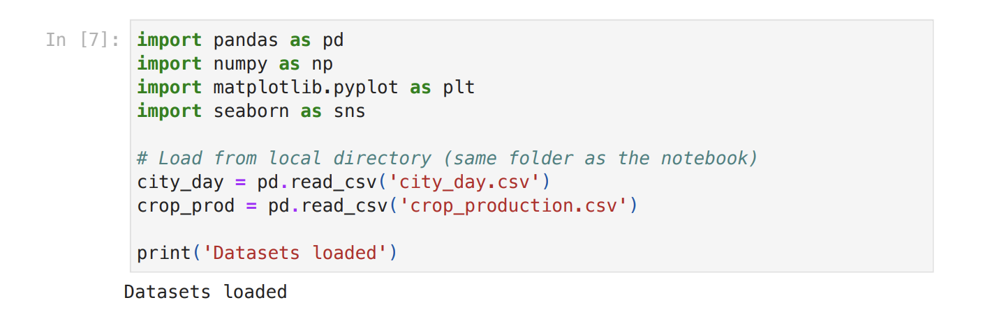
Task 1: Data Inspection and Profiling
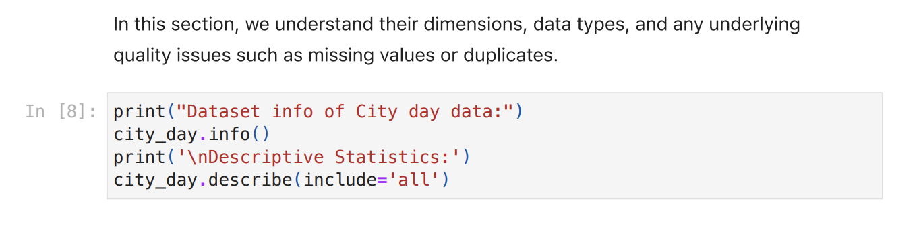
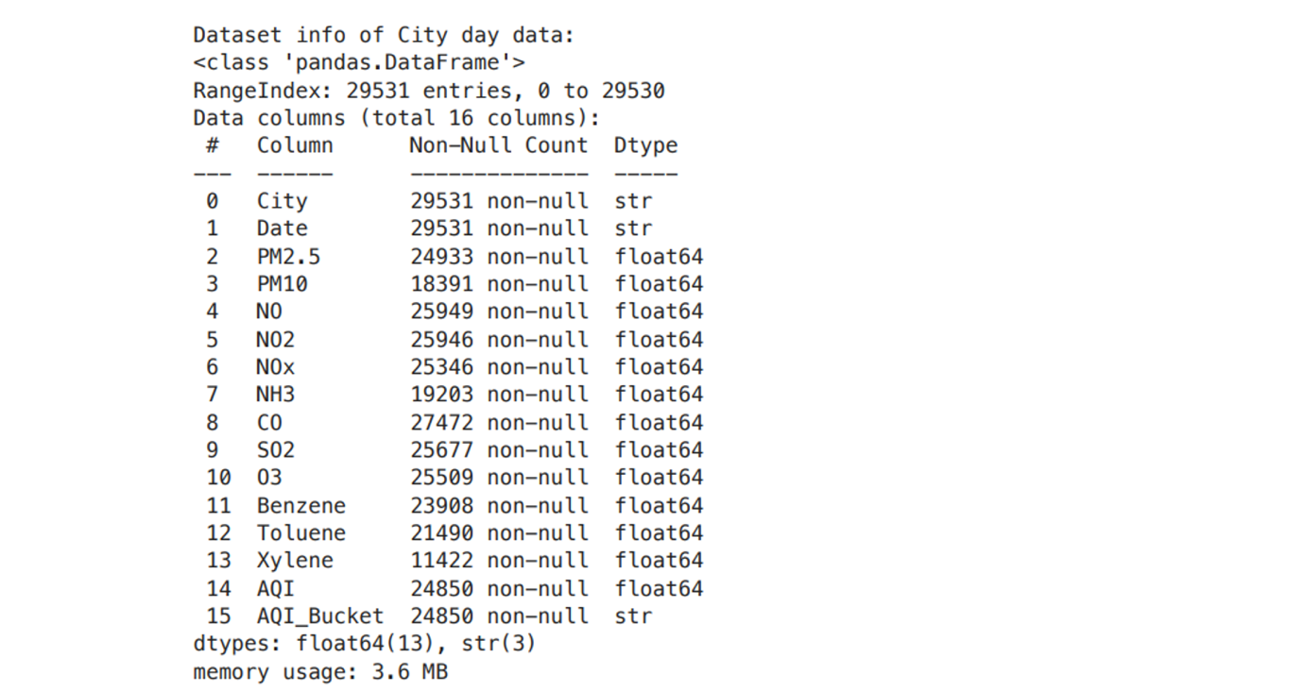

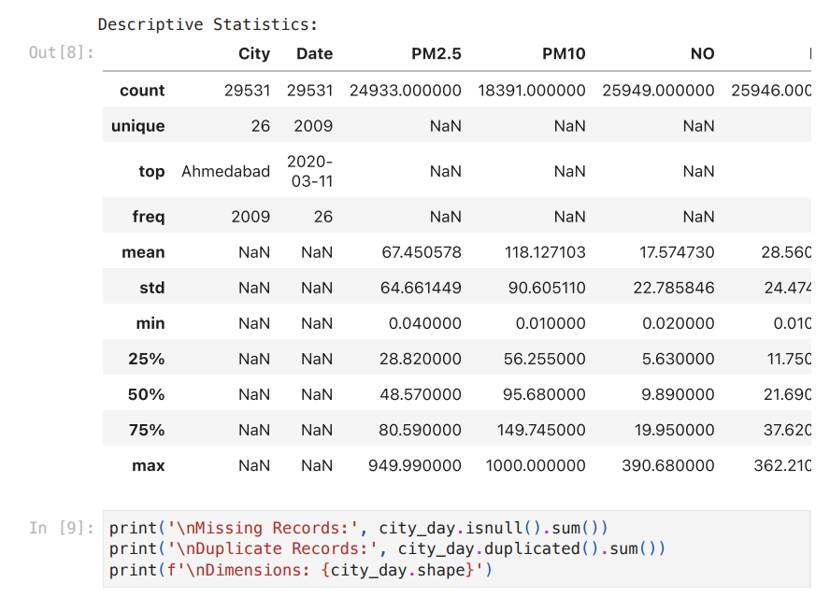
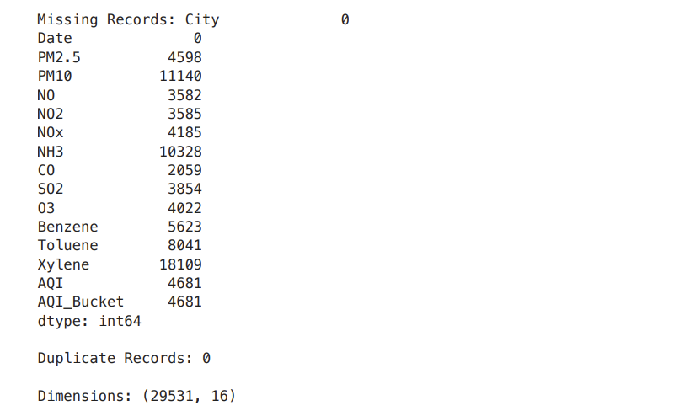

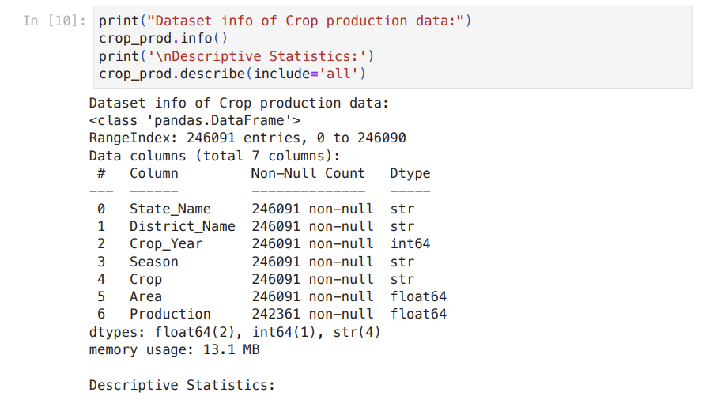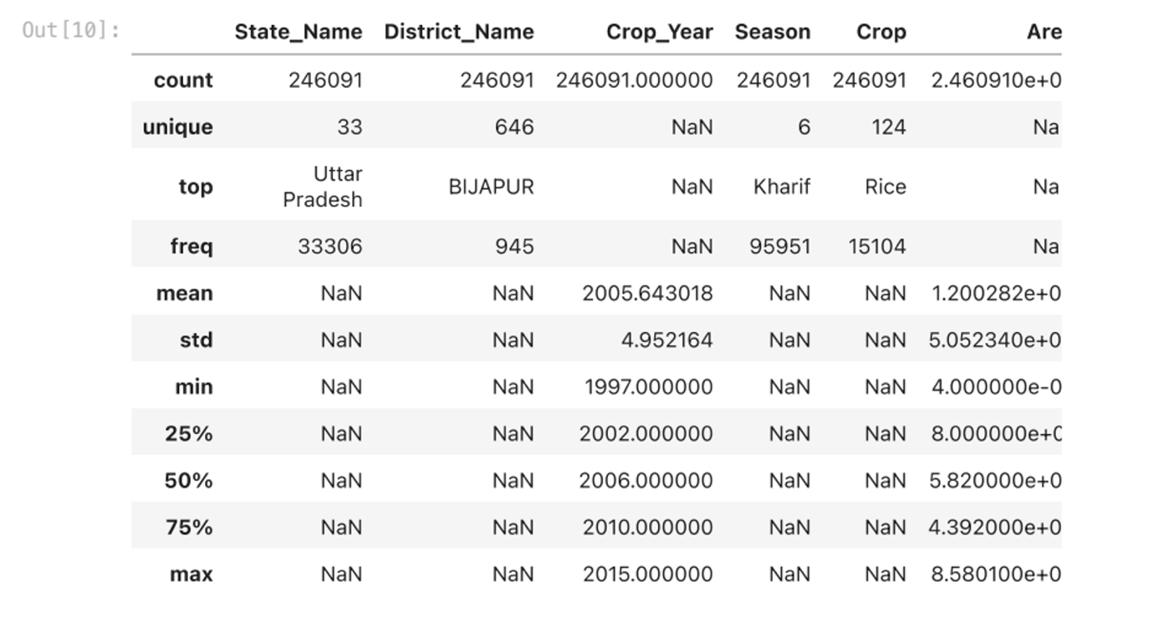
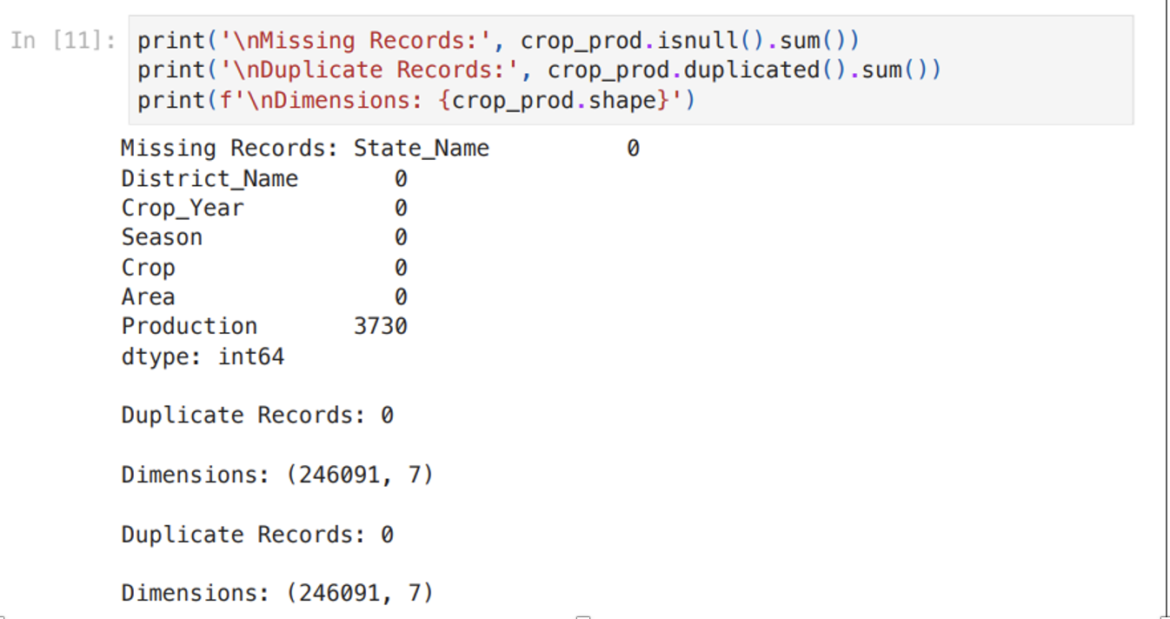
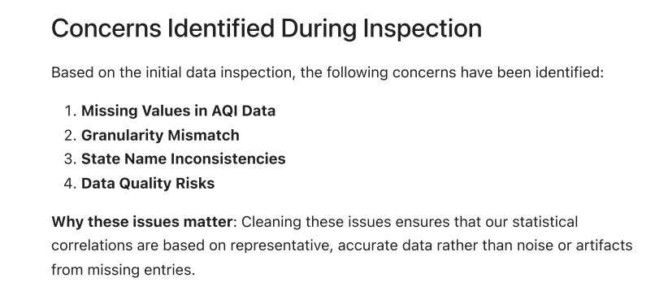
Task 2: Missing Value Treatment
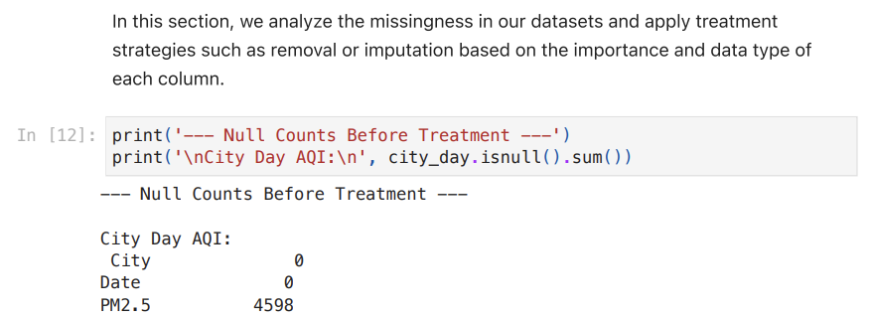
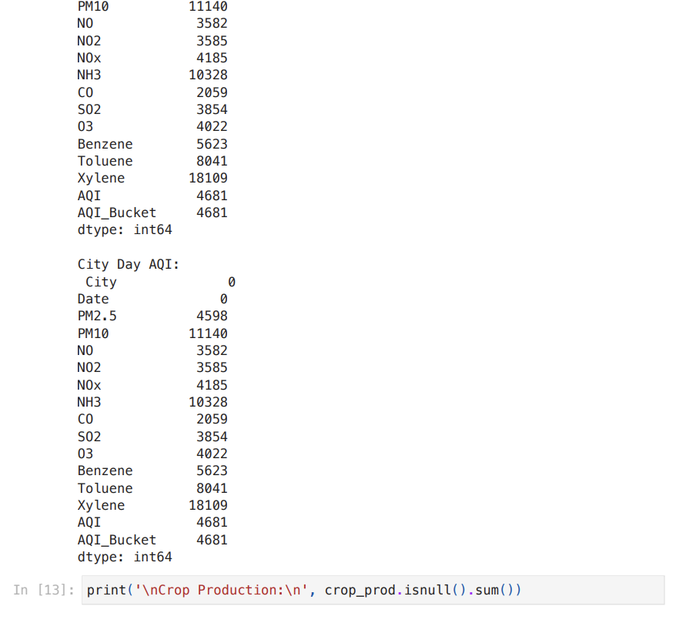
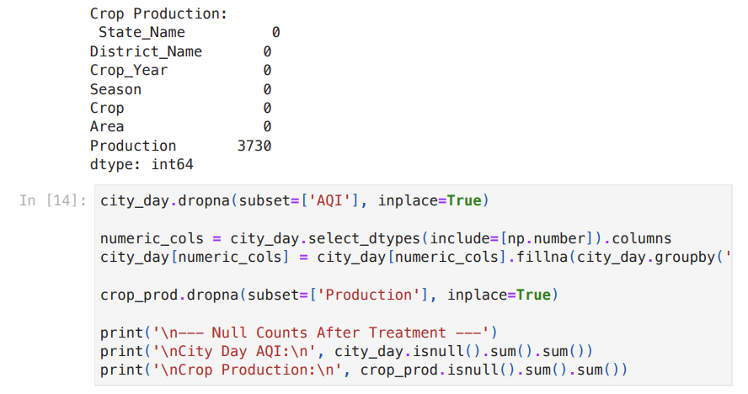
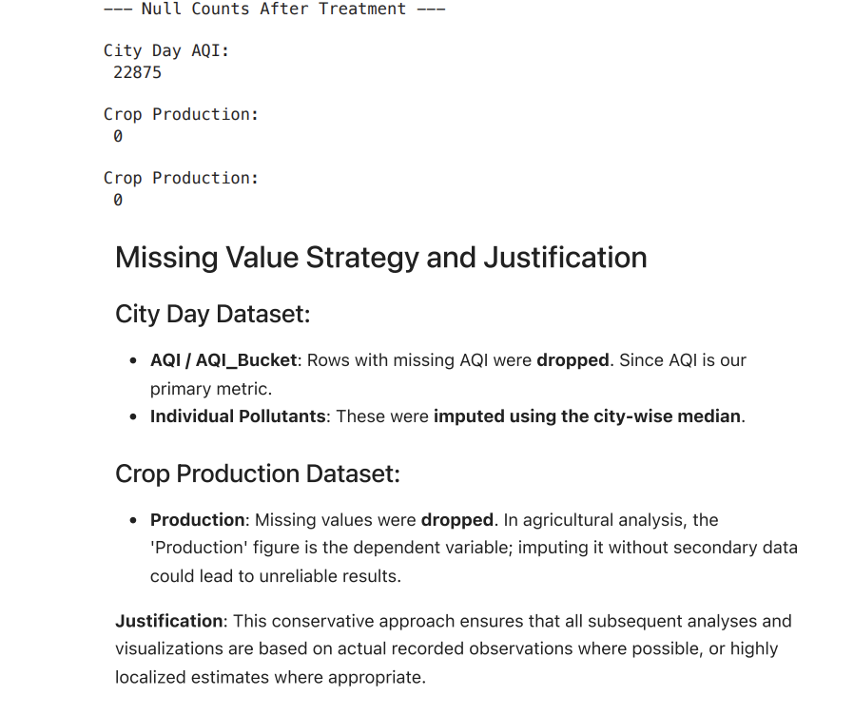
Task 3: Data Cleaning and Standardization
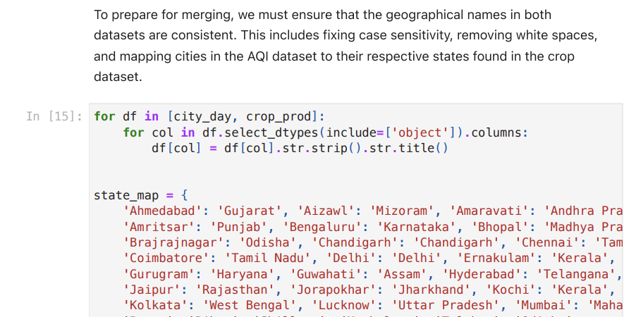
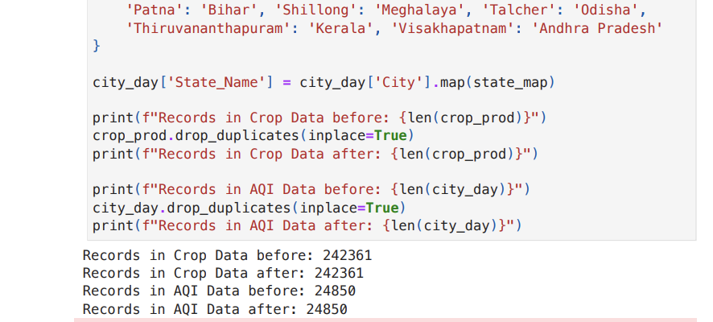
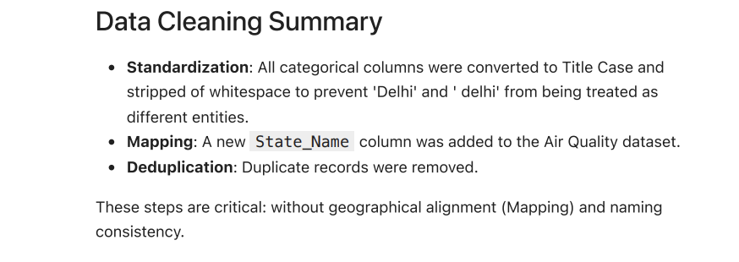
Task 4: AQI Distribution Analysis
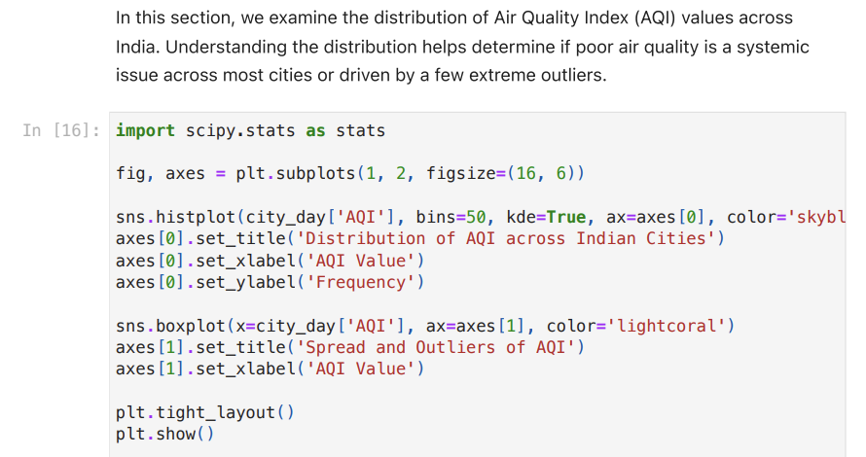
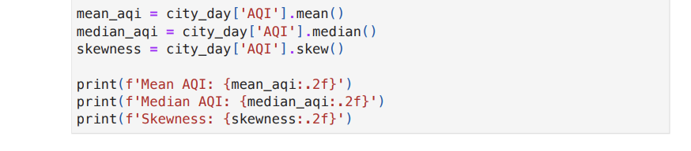
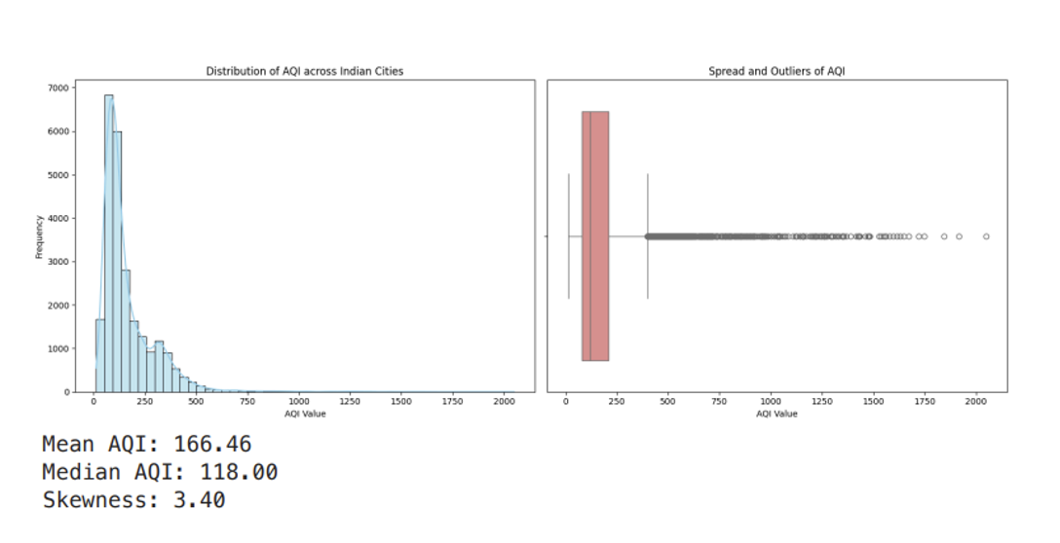
Task 5: Outlier Detection And Treatment
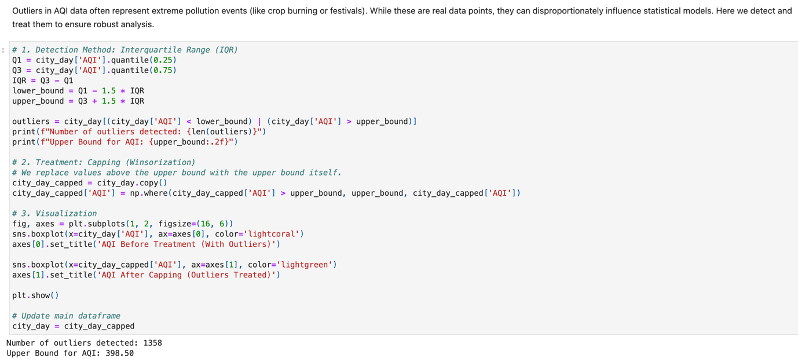



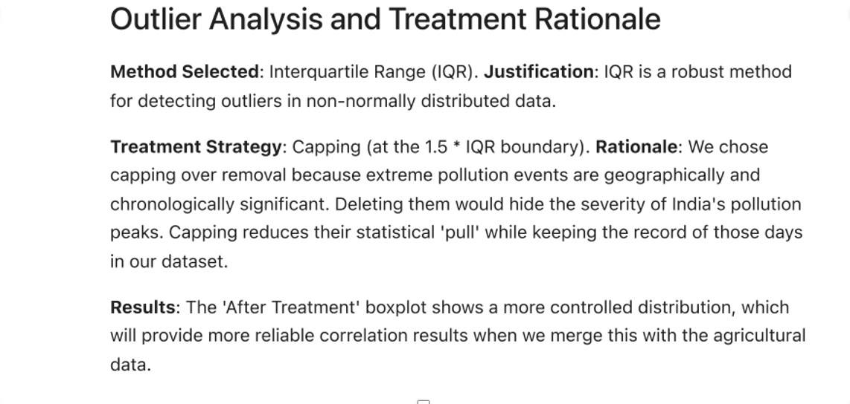
Task 6: AQI Trend Over Time
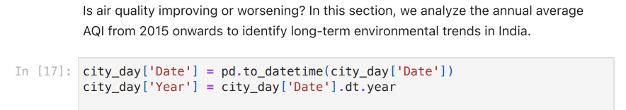
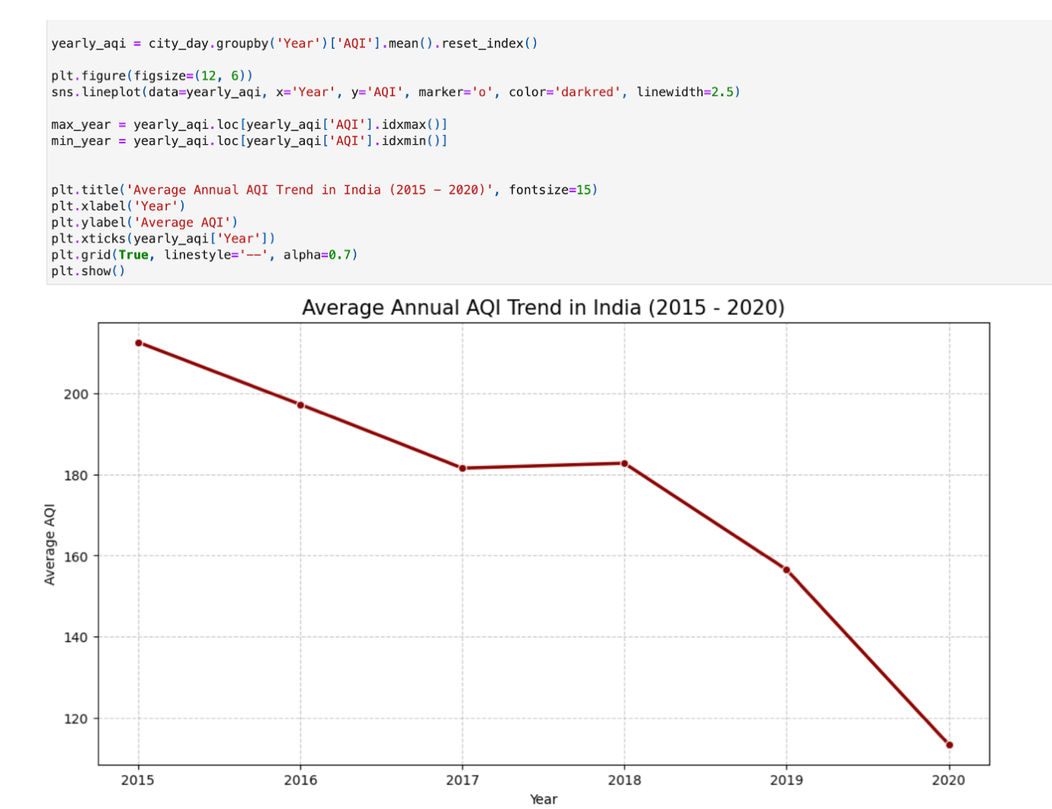
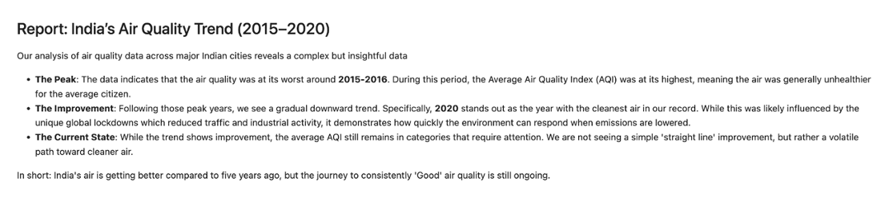Task 7: Seasonal AQI Analysis
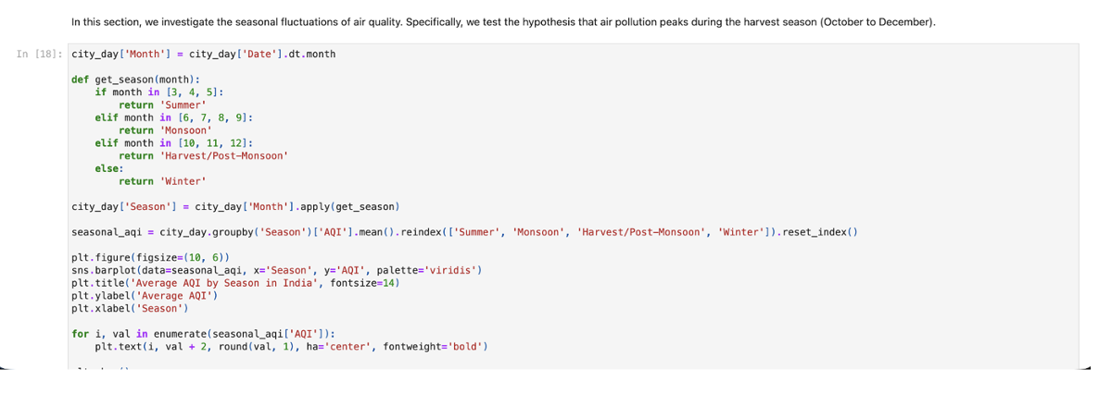

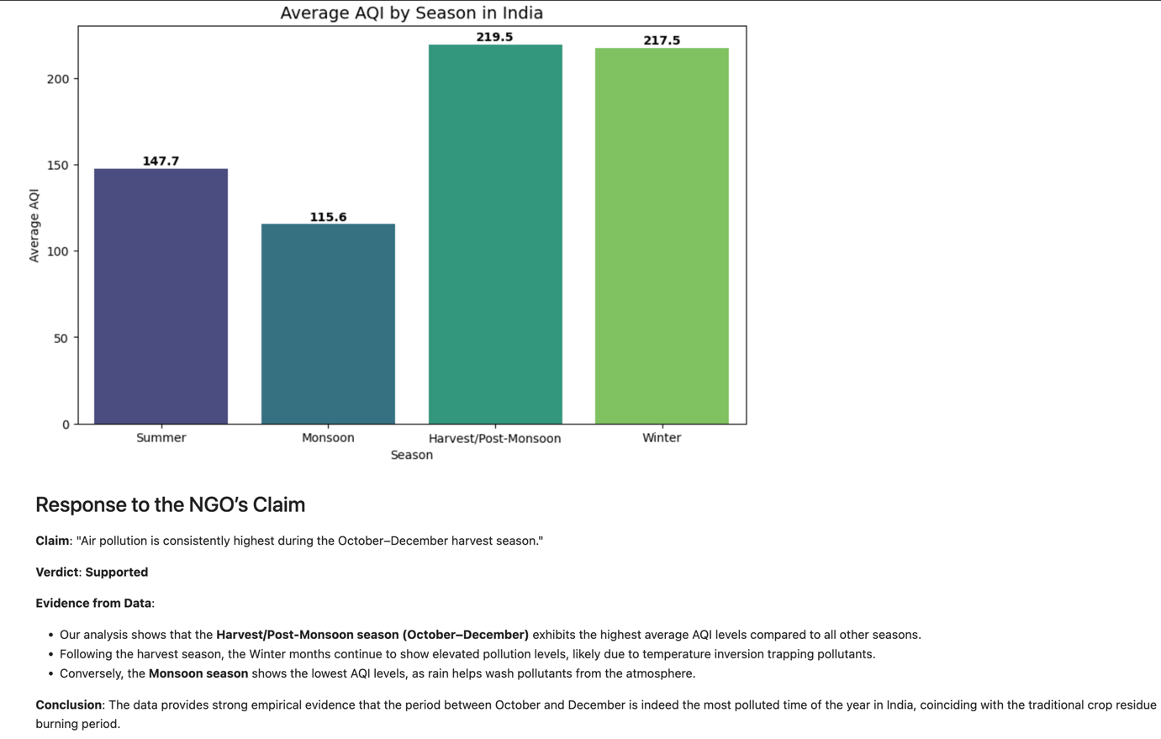
Task 8: Dataset Merging and Relationship Analysis
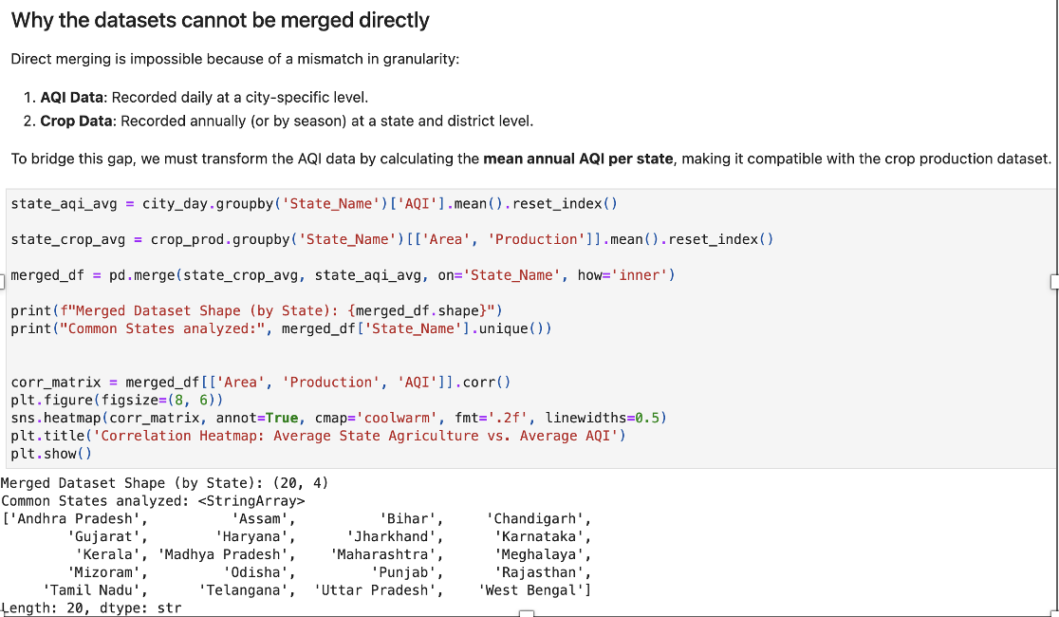

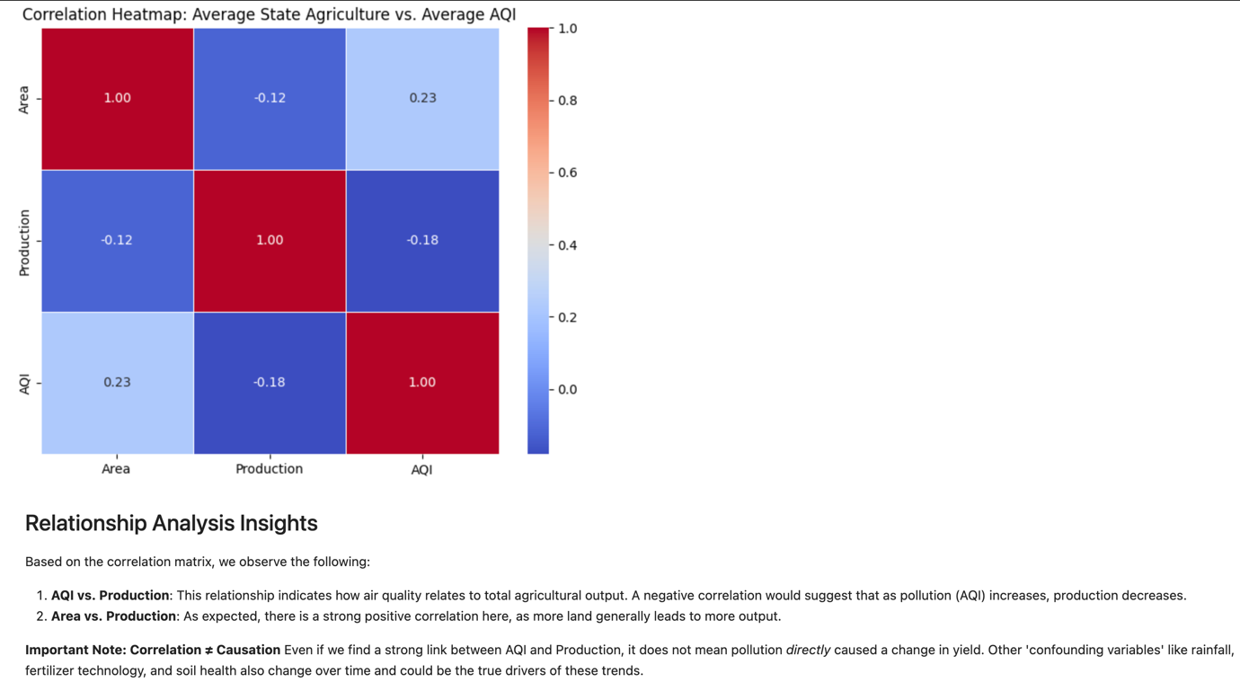
Task 9: Policy Brief for the Environment Minister
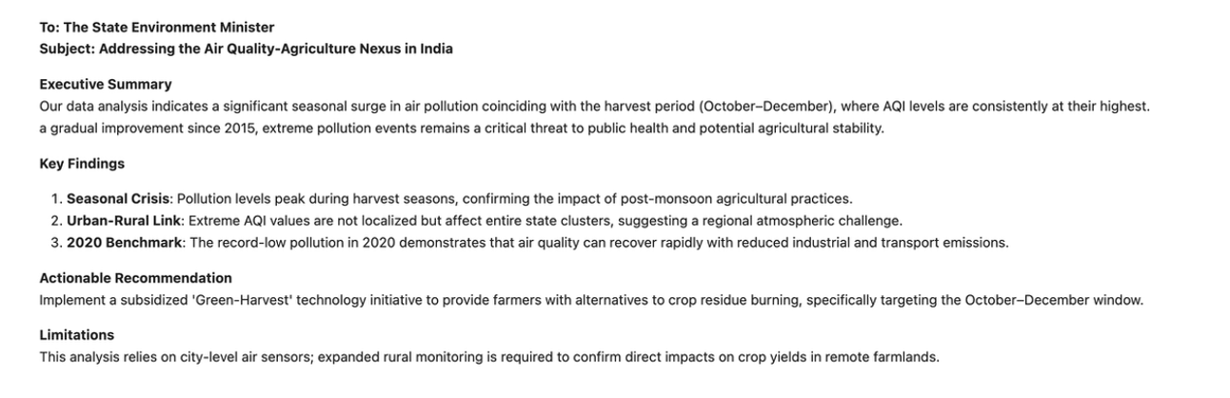
Optional Tasks: State Comparison & Final Insights
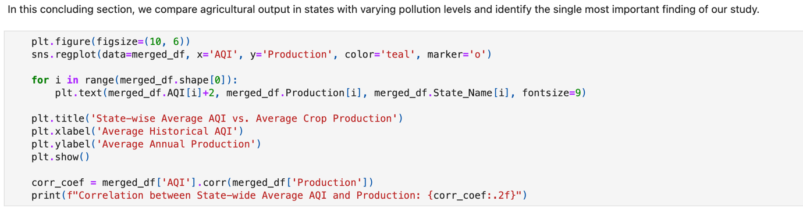

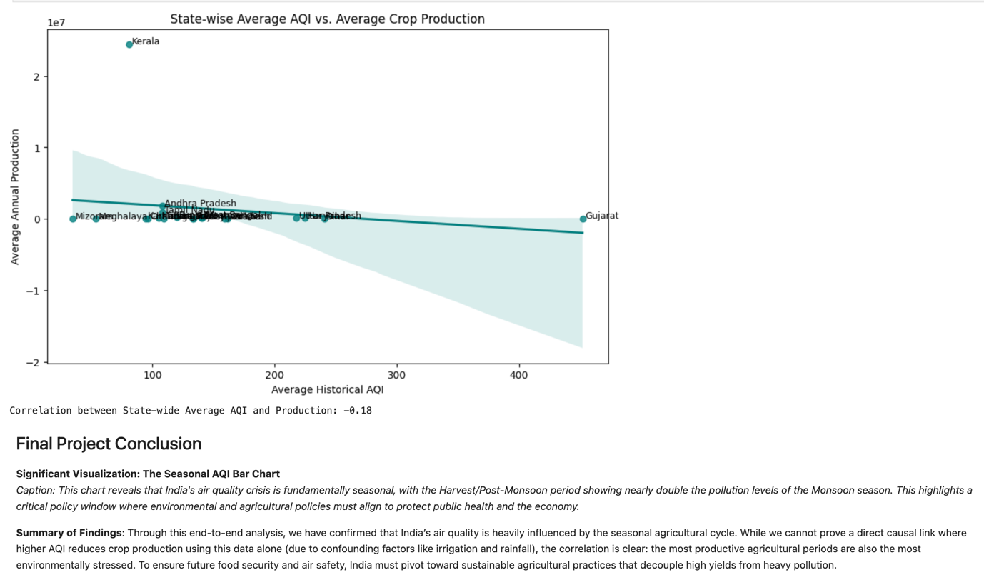
Conclusion/ Inference:
This study explored the relationship between air quality and agricultural production in India by analyzing historical AQI and crop production datasets. The results indicate that air pollution exhibits strong seasonal patterns, with the highest AQI levels occurring during the Harvest/Post-Monsoon season (October–December). This finding supports concerns that agricultural activities such as crop residue burning contribute significantly to seasonal air quality deterioration.
The long-term AQI trend suggests that air quality has shown gradual improvement between 2015 and 2020, although pollution levels remain high enough to warrant continued environmental intervention. Distribution analysis further revealed that AQI values are positively skewed.
After integrating the air quality and agricultural datasets, a weak negative correlation (r = -0.18) was observed between average AQI and crop production. Factors such as rainfall, irrigation facilities, soil fertility, crop variety, farming practices, and economic conditions likely play a substantial role in determining agricultural productivity.
Overall, the analysis highlights that air pollution remains a significant environmental concern, particularly during harvest periods. Although the evidence does not conclusively prove that poor air quality reduces crop production, it suggests that sustainable agricultural practices and pollution-control measures could benefit both environmental quality and long-term agricultural sustainability. Further studies incorporating additional agricultural and climatic variables would be necessary to establish a stronger understanding of the relationship between air quality and crop yield.

